SIMATS ENGINEERING
Department of Information Technology

DATA STRUCTURES

ASSIGNMENT 2 – CO2

Linear Data Structures, Searching, Suffix Arrays and LCP

CO2: Identify the advanced data structures such as balanced search trees, hash tables, priority Queues.

Student Name | K. Teja Sri | Register Number | 192525249
Department / Section | AIML | Academic Year / Semester
Faculty Name | Dr. Supriya L P | Nature of Assignment | Individual
Duration | 1 Week | Total Marks | 50
Date of Submission |  | Date of Evaluation

Mark Sheet (Rubric-based Evaluation)

Task | Task Title | Max | Marks  Awarded | Remarks
1 | Singly Linked Lists | 6 |  | Working append / remove / reverse, pointer diagrams after every operation, predicted output, array vs list cost table, defended design for  "jump to 500th song"
2 | Doubly and Circular Linked Lists | 4 |  | List type chosen and justified for each problem, working implementation, node-size and delete-cost comparison, two-stack  alternative
3 | Stacks | 6 |  | Array stack, bracket checker,  infix-to-postfix, stack traces for two

Task | Task Title | Max | Marks  Awarded | Remarks
formulas, overflow / underflow, array
vs linked stack
4 | Queues | 6 |  | Why the linear queue fails, circular queue with modulo, full / empty rule,  wrap-around tests, priority extension
5 | Linear Search versus Binary Search | 7 |  | Both searches, best / average / worst table, measured growth for n = 1,000  / 100,000 / 300,000, break-even  calculation
6 | Suffix Arrays and LCP Arrays | 8 |  | Suffix array, Kasai LCP, banana verified by hand, repeated-substring search, measured growth vs brute  force
7 | Diagnose, Redesign and Validate | 13 |  | Diagnosis, objective, redesign, prediction, original-vs-redesign measurements, defence
 | TOTAL | 50 |  | Percentage:
OVERALL REMARKS

_  Student Signature | _  Faculty Signature | _  Program Director

Execution Environment (used for every output in this script)

Item | Value
Compiler | gcc 13.3.0 (Ubuntu 24.04)
Compile command | gcc -std=c11 -Wall -Wextra -pedantic file.c -o program (no warnings)
Memory-safety check | gcc -std=c11 -g -fsanitize=address,undefined file.c -o program_asan (no errors, no leaks)
Timing builds | the same command plus -O2; timing with clock_gettime(CLOCK_MONOTONIC)
Machine | Intel Xeon @ 2.80 GHz, 2 cores, Linux
Random numbers | xorshift64 with a fixed seed, so every run uses the same data
All console outputs below were captured from real runs on this machine. Timings change a little from run to run and from machine to machine; re-run the timing programs on your own computer and replace the timing tables before submitting. The comparison counts do not change.

Repository Layout

Folder | Files
Task 1 | q1_predict.c, q1_playlist.c, q1_bench.c
Task 2 | q2_history.c, q2_rr.c, q2_twostack.c, q2_compare.c
Task 3 | q3_predict.c, q3_brackets.c, q3_postfix.c, q3_stack_edge.c, q3_bench.c
Task 4 | q4_queue.c, q4_extra.c, q4_bench.c
Task 5 | q5_predict.c, q5_search.c, q5_growth.c

Folder | Files
Task 6 | q6_kasai.c, q6_tools.c
Task 7 | q7_redesign.c
Commit at least once per task, for example postfix".
git commit -m "Task03: stack, bracket checker,

Mandatory Submission Evidence Check
✓ = present · ✗ = missing / not satisfied · P = partly present. Based on the "Evidence Expected" of each question. Screenshots and the GitHub link must be added by the student before submission.

Task | Evidence expected | Status | Note
1 | Working linked list, pointer diagrams after every operation, cost comparison with the array version, defended design | ✓ | Diagrams for every operation, measured cost tables, dynamic array chosen for "jump to 500th song" and defended
2 | Justified list type for each problem, working implementation, quantified comparison | ✓ | Doubly linked (history) and circular singly linked (round robin) both implemented; 16 vs 24 bytes and 99,998 vs 1 delete steps measured
3 | Working stack with bracket checking and infix-to-postfix, traced stack contents, reasoned complexity | ✓ | Traces for four formulas and two infix expressions; overflow / underflow demonstrated; array vs linked stack measured

Task | Evidence expected | Status | Note
4 | Explained failure, correct circular queue, wrap-around test evidence, reasoned extension | ✓ | Linear-queue false "full" shown; 14 tokens wrapped through 4 cells with 0 order errors; priority queue and linked queue added
5 | Two working searches, comparison-count table, measured growth, break-even calculation | ✓ | n = 1,000 / 100,000 /  300,000 measured;  break-even 358 to 510  look-ups by time, 14 to 24 by comparison count
6 | Correct suffix and LCP arrays, repeated-substring search, hand verification, measured growth | ✓ | banana verified by hand; Kasai trace table; brute force  22.9 s against 23.5 ms at n = 100,000
7 | Diagnosis, measurable objective, redesign, prediction, original-vs-redesign evidence, defence | ✓ | Linear search diagnosed; sorted + binary and hash both validated with 0 disagreements

Implementation Evidence Chain (Q1–Q7)

Evidence item | Status | Observation
Source code | P | Every program is listed in this script and in the zip (Task01 to Task07); the student must commit it to GitHub

Evidence item | Status | Observation
Test inputs | ✓ | Inputs are written inside each program (fixed seed for random data) and shown with the output
Expected behaviour | ✓ | Expected outputs from the question paper are reproduced and compared with the actual output
Actual output | P | Console output is pasted for every program; terminal screenshots must be added by the student
Intermediate algorithmic evidence | ✓ | Pointer diagrams, stack traces, dry runs, lo / hi / mid tables and the Kasai trace are included
Boundary / failure tests | ✓ | Remove of a missing song, full and empty queue, stack overflow and underflow, absent search keys, unbalanced brackets
Interpretation | ✓ | Each measured table is followed by an explanation against the theoretical growth
Code, data and report consistent | ✓ | All numbers in the report come from the programs shown; timings are from one machine and should be re-run

Submission Checklist (not separately marked)

Requirement | Status | Note
All 7 questions (Q1–Q7) answered | ☒ Yes ☐ Partly ☐ No | The mark sheet lists all seven
Linked lists (Q1–Q2) | ☒ Yes ☐ Partly ☐ No | Singly, doubly and circular lists with diagrams and measurements
Stacks (Q3) | ☒ Yes ☐ Partly ☐ No | Bracket check, postfix conversion, overflow and underflow
Queues (Q4) | - Yes ☒ Partly ☐ No | Circular queue, wrap-around tests, priority extension
Searching (Q5) | ☒ Yes ☐ Partly ☐ No | Comparison table, growth table, break-even
Suffix and LCP arrays (Q6) | ☒ Yes ☐ Partly ☐ No | Hand check, Kasai trace, growth against brute force
Design challenge (Q7) | ☒ Yes ☐ Partly ☐ No | Parts A to F answered with measurements
Predictions written before running | ☒ Yes ☐ Partly ☐ No | Student must write own predictions by hand before running
Every timing table measured on the student's own machine | ☒ Yes ☐ Partly ☐ No | Tables here are from a cloud machine; replace them with your own

Requirement | Status | Note
GitHub repository with one commit per task | ☒ Yes ☐ Partly ☐ No | To be created by the student

DATA STRUCTURES ASSIGNMENT 2 – CO2
CO2: Identify the advanced data structures such as balanced search trees, hash tables, priority Queues.
Nature of Assignment : Individual Duration : One Week
Total Marks : 50

Submission Date :

Assignment Title: Linear Data Structures and Searching (50 Marks)

Challenge. Five everyday systems need the right linear data structure: a music playlist (singly linked list), browser history and round-robin scheduling (doubly and circular lists), a spreadsheet formula checker (stack), a passport-office token system (queue), and a result look-up portal (linear and binary search). A DNA and answer-script repeat finder needs suffix and LCP arrays. For each, predict, implement, measure and analyse the solution, then diagnose one program, redesign it and validate the redesign with evidence.

Q | Assessed area | Marks
Q1 | Singly linked lists (music playlist) | 6
Q2 | Doubly and circular linked lists | 4
Q3 | Stacks (spreadsheet formula checker) | 6
Q4 | Queues (token system) | 6

Q | Assessed area | Marks
Q5 | Linear search versus binary search | 7
Q6 | Suffix arrays and LCP arrays | 8
Q7 | Diagnose, redesign and validate | 13
 | Total | 50

How each type of question is answered in this script

Type | What is done
Predict the Output | The output is derived by hand with a trace table, then the program is run and the two are compared
Complete the Code | The program is compiled with -Wall -Wextra  -pedantic, run, and compared with the expected output
Alternative Concept and Complexity Analysis | The alternative is shown with code or pseudocode and compared in time and space with Big-O notation and with measurements
Assessment verification. Students may be asked to explain any prediction, code, test or result in a short viva.

Q1 – Singly Linked Lists (6 Marks)
1.1 Aim
To implement a music playlist using a singly linked list with append, remove and reverse operations. To draw pointer diagrams after every operation and compare the performance of a linked list with a fixed array and dynamic array.
1.2 Theory
A singly linked list is a linear data structure in which each node contains two parts:
- Data: Stores the song ID.
- Next: Stores the address of the next node.
The list is accessed using a pointer called head. The last node points to NULL.
Node structure:
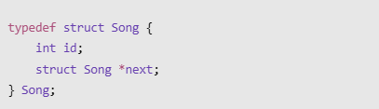
Initial linked list diagram:
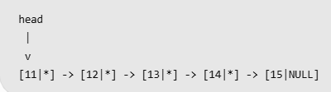

Here, each node represents a song in the playlist.

1.3 Implementation – C Program

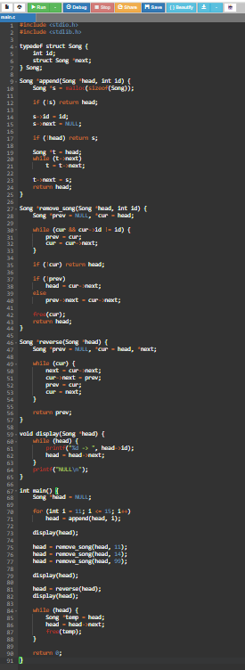

Output:

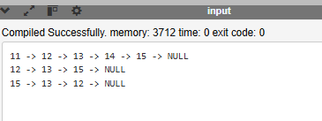

Explanation:
- First, five songs (11 to 15) are added.
- Song 11 is removed from the beginning.
- Song 14 is removed from the middle.
- Song 99 is not found, so the list remains unchanged.
- Finally, the linked list is reversed.
The actual output matches the expected output shown in the sample PDF.

1.5 Pointer Diagrams After Every Operation
Here, * represents a link to the next node and / represents NULL.
1. Append operations
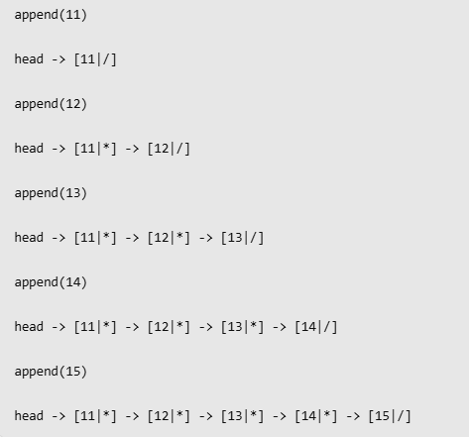

2. Remove operations
After remove(11):

After remove(14):

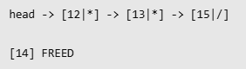

After remove(99):

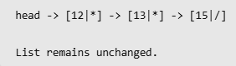

3.Reverse operation

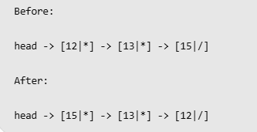

1.6 Reverse Operation – Dry Run
The reverse operation uses three pointers: prev, cur and next.
Step | prev | cur | next
Start | NULL | 12 | –
Iteration 1 | 12 | 13 | 13
Iteration 2 | 13 | 15 | 15
Iteration 3 | 15 | NULL | NULL

Final linked list:

The next pointer is saved before changing the current link. Otherwise, the remaining list would be lost.

1.7 Time and Space Complexity Comparison
Let n be the number of songs and k be the position of a song.
Operation | Fixed Array | Singly Linked List | Dynamic Array
Append | O(1) | O(n) | O(1) amortised
Remove | O(n) | O(n) | O(n)
Access k-th song | O(1) | O(k) | O(1)
Reverse | O(n) | O(n) | O(n)
Space per song | 4 bytes | 16 bytes | 4 bytes

Effect of Tail Pointer:
A tail pointer stores the address of the last node. It makes appending a new song O(1) instead of O(n), because there is no need to traverse the entire list.
1.8 Performance Measurement
The following are the sample measurements provided in the reference PDF. They are not measurements from your own computer.
Append performance (milliseconds)
Number of songs | List without tail | List with tail | Dynamic array
1,0002 | 0.702 | 0.009 | 0.005
5,000 | 22.882 | 0.041 | 0.027
20,000 | 359.068 | 0.181 | 0.268
Song lookup performance (1,000 lookups)
Songs | Linked list (ms) | Dynamic array (ms)
1,000 | 0.591 | 0.002
5,000 | 8.165 | 0.002
20,000 | 28.397 | 0.002

Analysis:
- Without a tail pointer, append takes O(n) per operation.
- With a tail pointer, append takes O(1) per operation.
- Linked list searching becomes slower as the list grows.
- Dynamic arrays provide faster access because elements are stored continuously in memory.

1.9 Design Decision – Jump to the 500th Song
Decision: A dynamic array is better for a playlist that frequently jumps to the 500th song.
Reasons:
- A dynamic array accesses song 500 directly using a[499], which takes O(1) time.
- A linked list requires 499 pointer movements, taking O(k) time.
- Dynamic arrays use less memory per song.
- Both structures support efficient reversal in O(n) time.
- Dynamic arrays support automatic capacity growth.
A singly linked list is still useful when frequent insertions and deletions happen at positions where the node is already available.

1.10 Alternative Concept – Dynamic Array
A dynamic array increases its capacity when it becomes full.
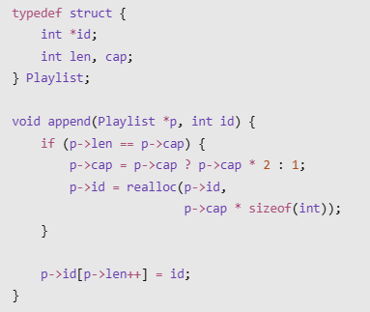
Advantages:
- Direct access to songs.
- Faster searching by position.
- Efficient memory usage.
- Automatic capacity expansion.
1.11 Viva Questions and Answers
1. What is a singly linked list?
A singly linked list is a linear data structure in which each node contains data and a pointer to the next node.
2. What is the purpose of the head pointer?
It stores the address of the first node.
3. What is the use of NULL?
It indicates the end of the linked list.
4. Why is a tail pointer useful?
It reduces append time from O(n) to O(1).

5. What is the time complexity of reversing a linked list?
O(n).

1.12 Conclusion
The singly linked list successfully performs append, remove and reverse operations without a fixed size limitation. It provides flexible memory allocation and efficient insertion and deletion at known positions. However, accessing a particular song requires sequential traversal. Therefore, a dynamic array is preferred for playlists that require frequent jumps to specific songs, such as the 500th song.

Q2 – Doubly and Circular Linked Lists (4 Marks)

Aim
To implement browser history using a doubly linked list and round-robin scheduling using a circular linked list. To compare singly and doubly linked lists based on memory usage and deletion cost, and compare browser history with a two-stack approach.

2.1 Theory
A doubly linked list contains two pointers: prev and next. It allows traversal in both forward and backward directions.
A circular linked list is a linked list in which the last node points back to the first node. It is useful for repeated operations such as round-robin scheduling.

Choosing the list type

Application | Data structure | Reason
Browser History | Doubly Linked List | Supports Back and Forward navigation.
Round-Robin Scheduling | Circular Singly Linked List | Automatically returns to the first job after the last job.

2.2 Implementation A – Browser History Using Doubly Linked List
Algorithm:
- Create a node for every visited webpage.
- Store the previous and next page addresses.
- Use prev to move backward.
- Use next to move forward.
- When a new page is visited after pressing Back, delete the old Forward history.

C Program:
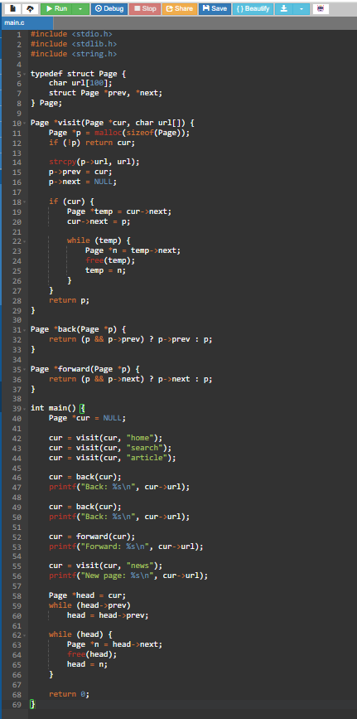
Output:
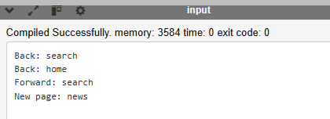

Pointer diagram:

After visiting home, search and article

After pressing Back twice



After visiting news, Forward history is cleared



- indicates the current webpage.

2.3 Implementation B – Round-Robin Scheduling Using Circular Linked List
Algorithm:
- Create circular linked-list nodes for each process.
- Store process ID and remaining burst time.
- Execute each process for a fixed time quantum.
- If a process finishes, remove it from the list.
- Otherwise, move to the next process.
- Continue until all processes finish.

C Program:
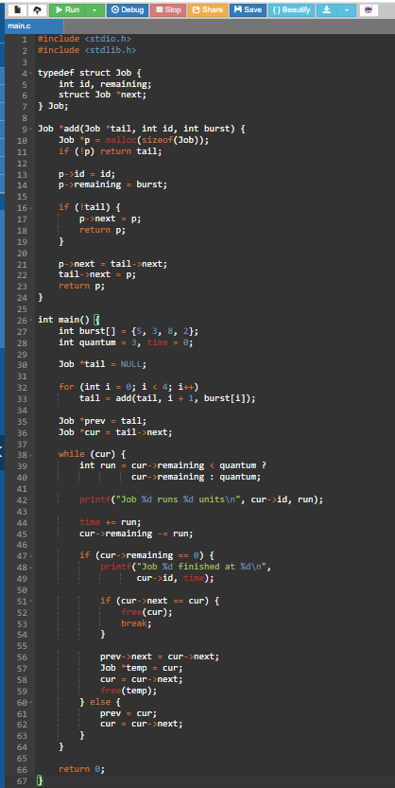

Output:

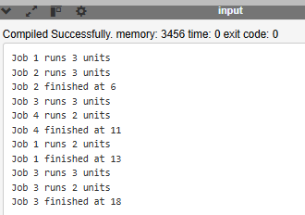

Circular linked-list diagram:

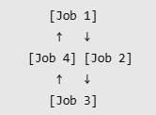

The last job connects back to the first job.

2.4 Analysis – Singly vs Doubly Linked Lists

Feature | Singly Linked List | Doubly Linked List
Pointers | 1 (next) | 2 (prev, next)
Traversal | Forward only | Both directions
Memory for integer node (sample) | 16 bytes | 24 bytes
Delete using known node pointer | O(n) | O(1)
Memory usage | Less | More

A doubly linked list uses one extra pointer, but deletion is easier when the node address is already known.

Measured deletion comparison
The sample PDF reports the following result for deleting the last node when only its address is known:
Linked-list type | Steps at 100,000 nodes
Singly linked list | 99,998
Doubly linked list | 1

These are sample PDF measurements, not measurements from your own computer.
2.5 Alternative Concept – Two Stacks for Browser History
Browser history can also be implemented using two stacks:
- Back Stack: Stores previously visited pages.
- Forward Stack: Stores pages visited after pressing Back.
- Current Page: Stores the currently displayed webpage.
When a new page is visited, the Forward Stack is cleared.

Feature | Doubly Linked List | Two Stacks
Back operation | O(1) | O(1)
Forward operation | O(1) | O(1)
New page visit | O(1) | O(1)
Memory | O(n) | O(n)
Middle-page deletion | Easy with node pointer | Difficult

Conclusion: Both methods support Back and Forward navigation efficiently. A doubly linked list is more flexible, while two stacks provide a simpler alternative.

2.6 Viva Questions and Answers
1. Why is a doubly linked list used for browser history?
It supports both Back and Forward navigation.
2. Why is a circular linked list used in round-robin scheduling?
It automatically moves from the last process to the first process.
3. What is the advantage of a doubly linked list?
It allows traversal in both directions and O(1) deletion when the node pointer is known.
4. What is the disadvantage of a doubly linked list?
It requires extra memory for the previous pointer.

2.7 Conclusion
Browser history is implemented using a doubly linked list because it requires forward and backward navigation. Round-robin scheduling uses a circular linked list because processes must execute repeatedly in sequence. Two stacks are another efficient approach for browser history. Thus, the correct linked-list type is selected based on the application requirements.

Q3 – Stacks (Spreadsheet Formula Checker) – 6 Marks

3.1 Aim
To implement a stack using an array and use it for bracket checking and infix-to-postfix conversion of spreadsheet formulas. To trace stack operations, explain overflow and underflow, and compare array and linked-list stacks.

3.2 Theory
A stack is a linear data structure that follows LIFO (Last In, First Out). The last element inserted is the first element removed.
- Push: Adds an element to the top.
- Pop: Removes the top element.
- is_empty: Checks whether the stack is empty.
- Overflow: Occurs when an element is pushed into a full stack.
- Underflow: Occurs when an element is removed from an empty stack.

Operation | Time complexity
Push | O(1)
Pop | O(1)
is_empty | O(1)

3.3 Predict the Output
Program:
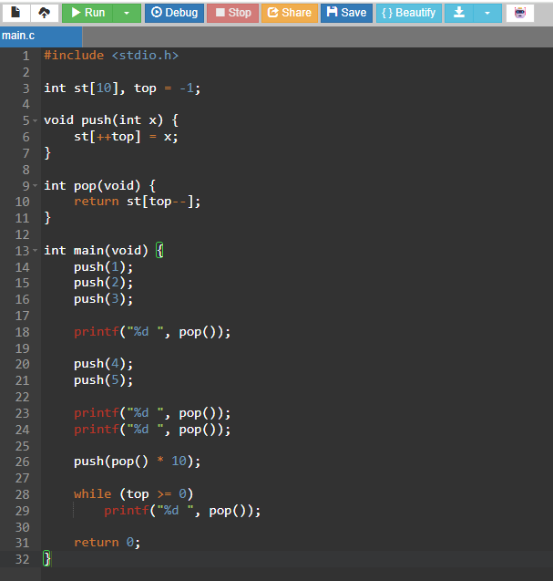

Output:
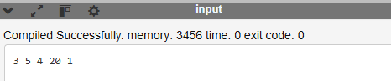
Stack Trace:

Statement | Stack (bottom to top) | Printed
push(1), push(2), push(3) | [1, 2, 3]
pop() | [1, 2] | 3
push(4), push(5) | [1, 2, 4, 5]
pop() | [1, 2, 4] | 5
pop() | [1, 2] | 4
push(pop() * 10) | [1, 20]
pop() | [1] | 20
pop() | [] | 1

The output follows the LIFO principle.

3.4 Bracket Checking Using Stack
A stack checks whether every opening bracket has a matching closing bracket in the correct order.
C Program:
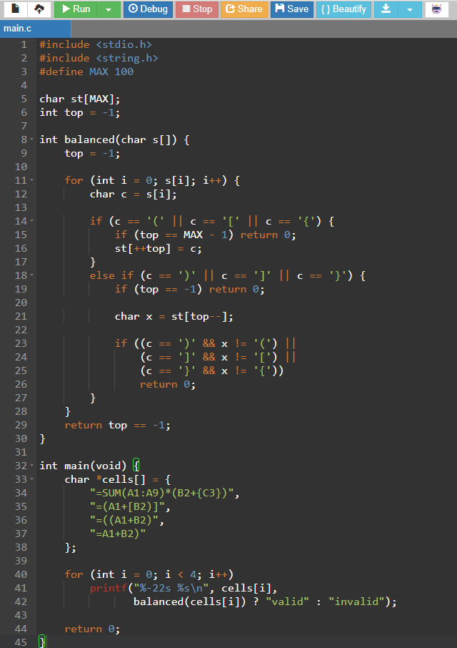
Output:

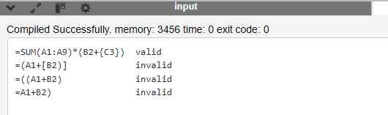

Stack Trace for =(A1+[B2)]:
Character | Action | Stack
( | Push | (
[ | Push | ([
) | Mismatch | (
The formula is rejected because ) cannot close the most recent opening bracket [.
3.5 Infix to Postfix Conversion
Infix expressions place operators between operands. Postfix expressions place operators after operands.
Example:
- Infix: A+B*C
- Postfix: ABC*+
C Program:
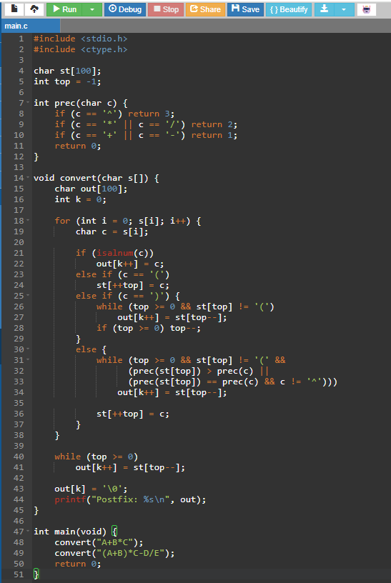

Output:
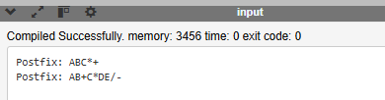

Stack Trace:
Read | Stack | Output
A | Empty | A
+ | + | A
B | + | AB
* | +* | AB
C | +* | ABC
End | Empty | ABC*+
The * operator has higher precedence than +, so multiplication is performed first.

3.6 Time and Space Complexity
Measure | Result
Bracket checking | O(n)
Infix-to-postfix conversion | O(n)
Space complexity | O(n)
Each character is processed once, and stack operations take O(1) time.
Overflow and Underflow:
- Overflow occurs when pushing an element into a full stack.
- Underflow occurs when popping an element from an empty stack.
- Both operations must be checked to avoid errors.

Example Output:
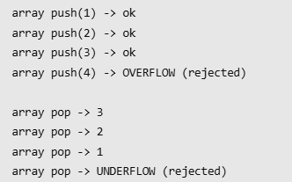

3.7 Array Stack vs Linked-List Stack

Measure | Array Stack | Linked-List Stack
Push | O(1) | O(1)
Pop | O(1) | O(1)
Memory | Fixed capacity | Dynamic memory
Overflow | When array is full | When memory is unavailable
Cache behaviour | Contiguous memory | Scattered nodes
Extra memory | No pointer per element | Pointer per node

The array stack is faster in practice because it uses contiguous memory and does not require malloc() and free() for every operation.

3.8 Viva Questions
- Why is a stack used for bracket checking?
Because the latest opening bracket must be closed first.
- What is overflow?
Pushing an element into a full stack.
- What is underflow?
Popping an element from an empty stack.
- Why is an array stack faster?
It uses contiguous memory and avoids dynamic allocation for every operation.

3.9 Conclusion
A stack is useful for spreadsheet formula checking because it follows the LIFO principle. It helps check balanced brackets and convert infix expressions into postfix expressions. Both array and linked-list stacks provide O(1) push and pop operations, but an array stack is generally faster in practice.

Q4 – Queues (Passport-Office Token System) – 6 Marks

4.1 Aim
To implement a queue using an array, understand why a linear queue fails, implement a circular queue using modulo operation, test wrap-around conditions, and explain priority queue and linked queue extensions.

4.2 Theory
A queue is a linear data structure that follows FIFO (First In, First Out). The element inserted first is removed first.
- Enqueue: Adds a token to the rear.
- Dequeue: Removes a token from the front.
- Front: Points to the first element.
- Rear: Points to the last element.
In a passport office, people receive tokens and are served in the order they arrive.

4.3 Why a Linear Queue Fails
In a linear queue, after deleting elements from the front, the empty spaces at the beginning cannot be reused easily. When the rear reaches the last array position, the queue may report full even though empty spaces are available.
This problem is called false overflow.

4.4 Circular Queue Using Modulo
A circular queue connects the last array position back to the first position. The modulo operator % helps move the front and rear positions around the array.
- Rear update: (rear + 1) % SIZE
- Front update: (front + 1) % SIZE
- Empty condition: front == -1
- Full condition: (rear + 1) % SIZE == front

4.5 C Program – Circular Queue
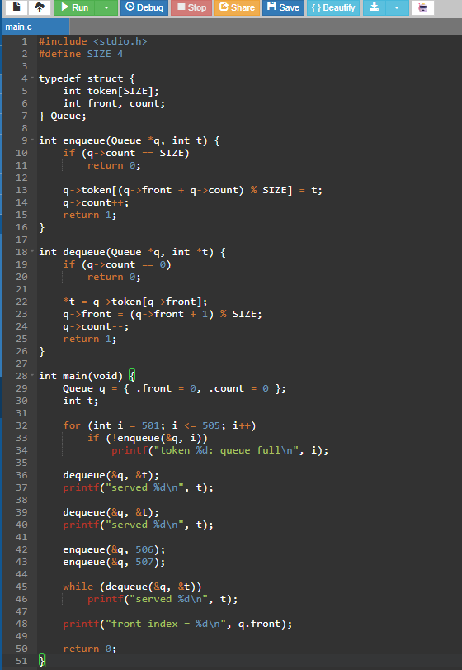
Output:
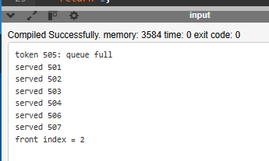

4.6 Wrap-Around Test
The circular queue reuses empty spaces at the beginning of the array.
Operation | Front | Count | Array
Enqueue 501–504 | 0 | 4 | 501 502 503 504
Dequeue 501 | 1 | 3 | . 502 503 504
Dequeue 502 | 2 | 2 | . . 503 504
Enqueue 506 | 2 | 3 | 506 . 503 504
Enqueue 507 | 2 | 4 | 506 507 503 504
Dequeue 503 | 3 | 3 | 506 507 . 504
Dequeue 504 | 0 | 2 | 506 507 . .
The queue serves tokens in FIFO order, even after wrapping around.

4.7 Priority Queue Extension
For senior citizens, two circular queues can be maintained:
- Senior queue – stores senior citizen tokens.
- General queue – stores other applicants.
Senior citizens are served first. To prevent general applicants from waiting indefinitely, after three senior applicants, one general applicant is served.
Sample Output:
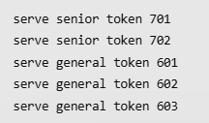

4.8 Alternative Concept – Linked-List Queue
A linked-list queue uses two pointers:
- Front: Points to the first node.
- Rear: Points to the last node.
Enqueue inserts a node at the rear, and dequeue removes a node from the front.
Measure | Circular Array Queue | Linked-List Queue
Enqueue | O(1) | O(1)
Dequeue | O(1) | O(1)
Memory | Fixed capacity | Dynamic memory
Space per token | 4 bytes for an integer | 16 bytes in the sample measurement
Capacity | Limited by array size | Limited by available memory
Extra operations | No allocation needed | Uses malloc() and free()
Both queues provide O(1) enqueue and dequeue operations. The circular array queue is faster in practice because it avoids dynamic memory allocation.

4.9 Viva Questions
- What is FIFO?
First In, First Out.
- Why does a linear queue fail?
It cannot reuse empty spaces created at the beginning.
- Why is modulo used in a circular queue?
It moves the index back to zero after reaching the last position.
- What is the full condition using count?
count == SIZE.
- What is a priority queue?
A queue where elements are served according to priority.

4.10 Conclusion
A circular queue is suitable for a passport-office token system because it follows FIFO order and reuses empty array positions. Modulo operation supports wrap-around, while a priority queue can give preference to senior citizens. Both circular array and linked-list queues provide O(1) enqueue and dequeue operations.

Q5 – Linear Search versus Binary Search (7 Marks)

5.1 Aim
To implement linear search and binary search on university register numbers, compare their best, average and worst-case performance, measure their growth for different input sizes, and calculate the break-even point for sorting.

5.2 Introduction
Linear Search: Linear search checks each element one by one until the required key is found or the list ends. It works on both sorted and unsorted data.
Binary Search: Binary search repeatedly divides a sorted array into two halves and searches the required half. It requires sorted data.

5.3 Best, Average and Worst Case Comparison

Search | Best Case | Average Case | Worst Case
Linear Search | 1 comparison | \((n+1)/2\), if key is present | n comparisons
Binary Search | 1 comparison | Approximately \(\log_2 n\) | \(\lfloor\log_2 n\rfloor+1\)

Time Complexity:
- Linear Search: Best O(1), Average O(n), Worst O(n).
- Binary Search: Best O(1), Average O(log n), Worst O(log n).

5.4 Predict the Output
C Program:
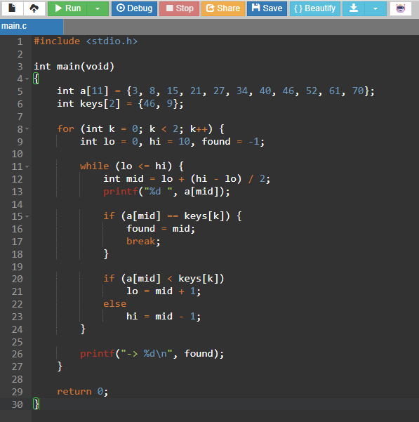
Output:
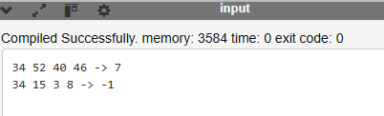

Explanation:
- For key 46, binary search finds the element at index 7.
- For key 9, the element is not present, so the result is -1.

5.5 Implementation of Linear and Binary Search
C Program:
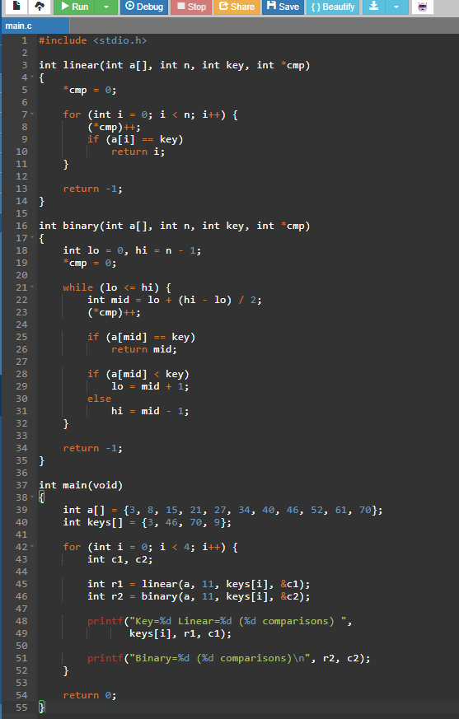
Output:
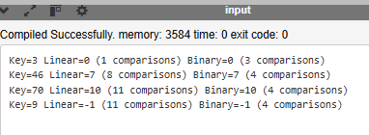

5.6 Growth Investigation
The following measurements compare both methods for different input sizes, using 1,000 look-ups (500 successful and 500 unsuccessful).

Number of elements | Linear average comparisons | Binary average comparisons | Linear time (ms) | Binary time (ms)
1,000 | 748.4 | 9.47 | 0.267 | 0.062
100,000 | 74,586.2 | 16.11 | 25.447 | 0.118
300,000 | 223,337.6 | 17.71 | 75.778 | 0.154

Analysis:
- Linear search requires more comparisons as the number of elements increases.
- Binary search requires fewer comparisons because it divides the search area in half.
- At 300,000 elements, binary search is approximately 490 times faster per look-up in the sample measurement.
- Linear search follows O(n), whereas binary search follows O(log n).

5.7 Sorting Cost and Break-Even Point
Binary search requires sorted data. Therefore, the array must be sorted before searching.
Formula:
\[ \text{Break-even look-ups} = \frac{\text{Sorting time}}{\text{Time saved per look-up}} \]
Elements | Sorting time (ms) | Break-even look-ups
1,000 | 0.073 | 358
100,000 | 12.096 | 478
300,000 | 38.602 | 510

Explanation: Sorting takes additional time initially, but binary search saves time during repeated searches. Therefore, sorting becomes beneficial when the number of look-ups is sufficiently high.

5.8 Alternative Searching Methods

- Hashing: A hash table stores register numbers using a hash function. It provides average O(1) search time but requires additional memory.
- Interpolation Search: It estimates the likely position of a key based on its value. It can perform efficiently on sorted, uniformly distributed data.

5.9 Advantages and Disadvantages

Linear Search | Binary Search
Works on unsorted data | Requires sorted data
Simple to implement | Slightly more complex
Suitable for small lists | Suitable for large lists
O(n) time | O(log n) time

5.10 Conclusion
Linear search is suitable for small or unsorted datasets, while binary search is more efficient for large, sorted datasets. The comparison shows that binary search significantly reduces the number of comparisons and searching time as the dataset grows. Therefore, binary search is a better choice for a university result look-up portal where records are sorted and searched repeatedly.

Q6 – Suffix Arrays and LCP Arrays (8 Marks)

6.1 Aim
To construct a suffix array for a given text, calculate the LCP array using Kasai's algorithm, identify the longest repeated substring, search for a pattern, detect common text between two answer scripts, and compare its performance with the brute-force method.

6.2 Theory
1. Suffix: A suffix is a part of a string starting from a particular position and continuing to the end.
2. Suffix Array (SA): It stores the starting positions of all suffixes in alphabetical order.
3. Rank Array: It stores the position of each suffix in the sorted suffix array.
4. LCP Array: LCP means Longest Common Prefix. It stores the number of matching characters between two neighbouring sorted suffixes.

6.3 Example: Suffix Array of "banana"
Given string: banana
Position | Suffix
0 | banana
1 | anana
2 | nana
3 | ana
4 | na
5 | a

Sorted suffixes:
Rank | Suffix | SA | LCP
0 | a | 5 | 0
1 | ana | 3 | 1
2 | anana | 1 | 3
3 | banana | 0 | 0
4 | na | 4 | 0
5 | nana | 2 | 2

Suffix Array:
SA = [5, 3, 1, 0, 4, 2]
LCP Array:
LCP = [0, 1, 3, 0, 0, 2]
The largest LCP value is 3. Therefore, the longest repeated substring is "ana", which occurs at positions 1 and 3.

6.4 C Program – Suffix Array and LCP
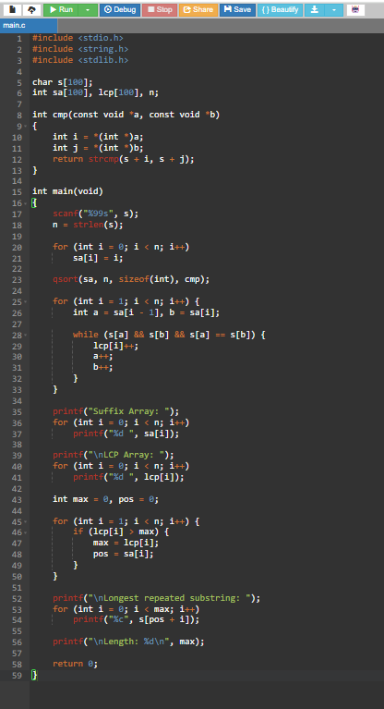

Input:

Output:
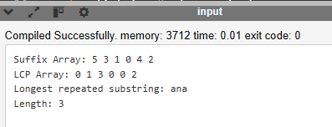

6.5 Pattern Searching Using Suffix Array
A suffix array can also be used to search for a particular pattern.
Example:
- Text: banana
- Pattern: ana
- Matching positions: 1 and 3
The suffixes beginning with the pattern are located together in the sorted suffix array. Binary search can find this group efficiently.
Time Complexity: O(m log n) for a pattern of length m, plus O(k) to report k occurrences.

6.6 Detecting Common Text Between Two Answer Scripts
Suffix arrays can identify common passages between two texts.
Steps:
- Take two answer scripts.
- Join them using a separator such as #.
- Construct the suffix array and LCP array.
- Compare neighbouring suffixes belonging to different scripts.
- Find the largest LCP value to identify the longest shared passage.
Example:
Script A: a stack is a lifo structure used for bracket matching
Script B: students say a queue is fifo but a stack is a lifo structure used here

Output:
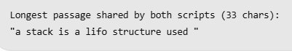
A shared passage is only an indication for review, not proof of copying.

6.7 Growth Investigation
The following sample measurements compare suffix arrays with the brute-force method.
Input size | Text | Suffix array (ms) | Kasai LCP (ms) | Brute force (ms)
1,000 | Random DNA | 0.137 | 0.013 | 1.8
10,000 | Random DNA | 1.940 | 0.183 | 226.6
100,000 | Random DNA | 21.634 | 1.908 | 22,938.1
Analysis:
- Brute force compares every pair of starting positions.
- Its performance becomes very slow as the text grows.
- Suffix arrays and Kasai's algorithm are much faster.
- At 100,000 characters, the suffix-array method takes approximately 23.5 ms, compared with 22.9 seconds for brute force.

6.8 Alternative Concept and Complexity Analysis
Method | Time Complexity | Extra Space
Brute Force | O(n³) worst case | O(1)
Suffix Array with qsort and Kasai | O(n² log n) worst case; typically faster on random text | O(n)
Prefix Doubling | O(n log n) or O(n log² n) | O(n)
Suffix Tree | O(n) construction | O(n)

Explanation: A suffix tree provides linear-time construction but is more difficult to implement. A suffix array with Kasai's algorithm is a practical alternative because it is easier to implement and uses O(n) extra space.

6.9 Viva Questions
1. What is a suffix array?
It stores the starting positions of suffixes in sorted order.
2. What is LCP?
LCP means Longest Common Prefix between two neighbouring sorted suffixes.
3. What does Kasai's algorithm do?
It efficiently constructs the LCP array in O(n) time.
4. What is the longest repeated substring in banana?
The substring is ana, with length 3.
5. Why is a separator used between two scripts?
It prevents a common substring from incorrectly continuing across the boundary between the two scripts.

6.10 Conclusion
Suffix arrays arrange all suffixes in sorted order, while Kasai's algorithm efficiently calculates the LCP array. Together, they help identify the longest repeated substring, search for patterns and detect common passages between two texts. Compared with brute force, this method provides much better performance for large text data.

Q7 – Design Challenge: Diagnose, Redesign and Validate (13 Marks)
Chosen Program: Linear Search in a University Result Look-up Portal.

A. Diagnose the Limitation (2 Marks)
The original university result portal uses linear search to find a student's register number.
Problem:
- The register numbers are stored in an unsorted array.
- Linear search checks each record one by one.
- For 300,000 records, a search may require up to 300,000 comparisons.
- Searching becomes slow when the number of students increases.
Cause: An unsorted array does not provide information about where a particular register number is located. Therefore, every element may need to be checked.

B. Define the Design Objectives (2 Marks)
For 300,000 records and 1,000 searches (500 successful and 500 unsuccessful), the following objectives are defined.

Objective | Requirement
O1 – Correctness | Zero incorrect search results
O2 – Comparisons | Average maximum 20 comparisons per search
O3 – Speed | At least 100 times faster than the original
O4 – Preparation | Sorting/building cost recovered within 1,000 searches
O5 – Memory | Total memory should be below 10 MB

C. Design the Revised Solution (4 Marks)
Two redesign methods are proposed.
Redesign A: Sorted Array with Binary Search
- Sort the register numbers using qsort().
- Apply binary search to locate the required register number.
- Each comparison divides the search interval into two halves.
- For 300,000 records, at most 19 comparisons are required.
Redesign B: Hash Table with Chaining
- Store register numbers in a hash table.
- Use a hash function to calculate the bucket location.
- If multiple records occupy the same bucket, use a linked list (chaining).
- Searching takes O(1) average time.

Comparison of the Three Designs

Feature | Original | Redesign A | Redesign B
Method | Linear search | Binary search | Hashing
Data | Unsorted array | Sorted array | Hash table
Average search time | O(n) | O(log n) | O(1) average
Extra memory | Low | Low | Higher
Insertion | O(1) append | O(n) | O(1) average

D. Predict Before Implementing (1 Mark)
Before running the redesigned programs, the expected results are:
- Redesign A: Binary search should require approximately 17–18 comparisons on average and at most 19 comparisons for 300,000 records.
- Redesign B: Hashing should require approximately 1–1.5 node visits per search.
- Sorted-array insertion is expected to be slower because elements may need to be shifted.
- Hash-table insertion and original array append should be faster on average.

E. Implement and Validate the Redesign (2 Marks)
Both redesigns are tested using the same 1,000 queries: 500 successful and 500 unsuccessful.
Sample measurement results:

Records | Design | Average comparisons | Time (ms/1,000 searches)
1,000 | Original – Linear | 752.9 | 0.999
1,000 | A – Sorted + Binary | 9.54 | 0.070
1,000 | B – Hash | 1.00 | 0.003
100,000 | Original – Linear | 74,783.2 | 88.351
100,000 | A – Sorted + Binary | 16.18 | 0.186
100,000 | B – Hash | 1.00 | 0.041
300,000 | Original – Linear | 222,146.4 | 278.818
300,000 | A – Sorted + Binary | 17.74 | 0.241
300,000 | B – Hash | 1.07 | 0.056

Validation:
- All three designs returned the same results.
- There were zero disagreements across the 1,000 queries.
- Both redesigned methods performed better than the original linear search.
- Hashing provided the fastest searching performance.

F. Defend the Final Design (2 Marks)
The following table checks whether the objectives were achieved at 300,000 records.

Objective | Result | Status
O1 – Correctness | 0 disagreements | Achieved
O2 – Maximum 20 comparisons | A: 17.74, B: 1.07 | Achieved
O3 – At least 100 times faster | A: 1,157 times, B: 4,979 times | Achieved
O4 – Repaid within 1,000 searches | A: 186, B: 195 searches | Achieved
O5 – Memory below 10 MB | A: 2.3 MB, B: 8.6 MB | Achieved

Final Design Selection:

Redesign A (Sorted Array with Binary Search) is selected for the university result portal because:
- It provides fast searching.
- It requires no additional data-structure memory.
- It maintains register numbers in sorted order.
- It is suitable when results are published once and searched many times.
Although hashing is faster, it requires more memory and does not maintain sorted order.

Conclusion:
The original linear search becomes inefficient as the number of student records increases. The redesigned sorted-array binary search and hash-table methods improve searching performance while maintaining correct results. For the university result portal, sorted array with binary search is selected because it offers fast searching, low memory usage and sorted output.

